FIREWALL EXPLORATION LAB

SEED 2.0

Contents

Environment Setup 2

Task 1 5

Task 1.A 6

Task 1.B 8

Subtask 1 9

Subtask 2 11

Subtask 3 19

Task 2 26

Task 2.A 29

Task 2.B 30

Task 2.C 32

Task 3 34

Task 3.A 34

ICMP Experiment 34

UDP Experiment 34

TCP Experiment 35

Task 3.B 37

Task 4 41

Task 5 42

# Environment Setup

Building docker containers.

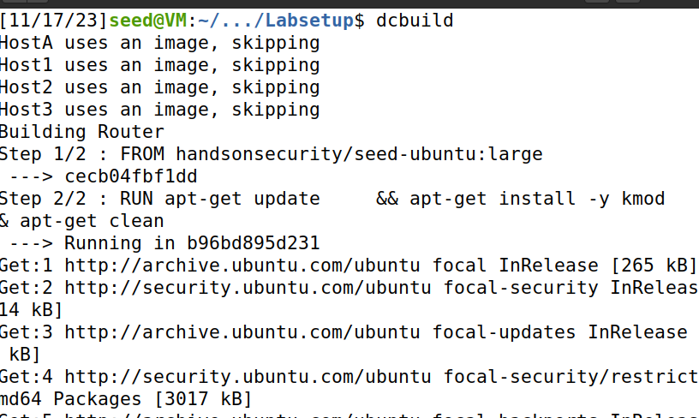

Setting up dockers.

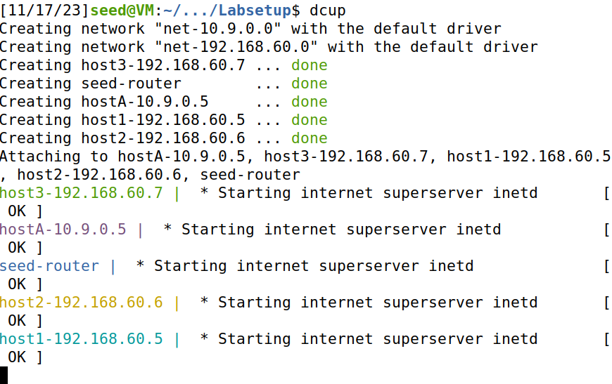

Setting the docker for Host A.

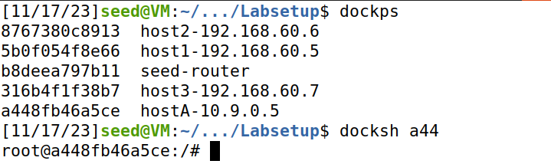

Setting up docker for Seed Router and following is the IP address of Seed Router.

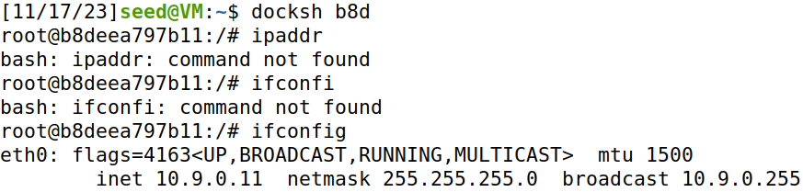

Setting up Host1 docker.

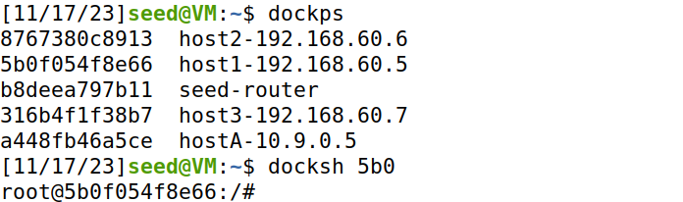

Setting up Host2 docker.

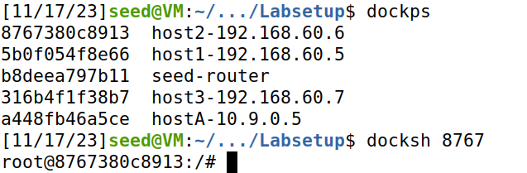

Setting up Host3 docker.

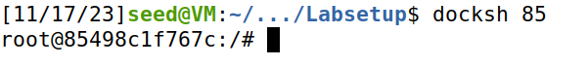

# Task 1

Compiling the program.

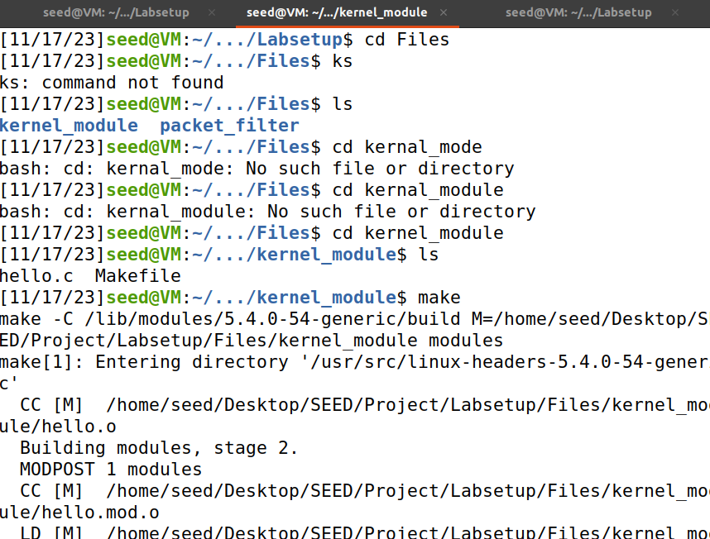

## Task 1.A

I checked the messages with dmesg and then proceeded to checking messages for kernal modules on wait where when I ran ‘sudo insmod hello.ko’ so I received this message from the given kernal module.

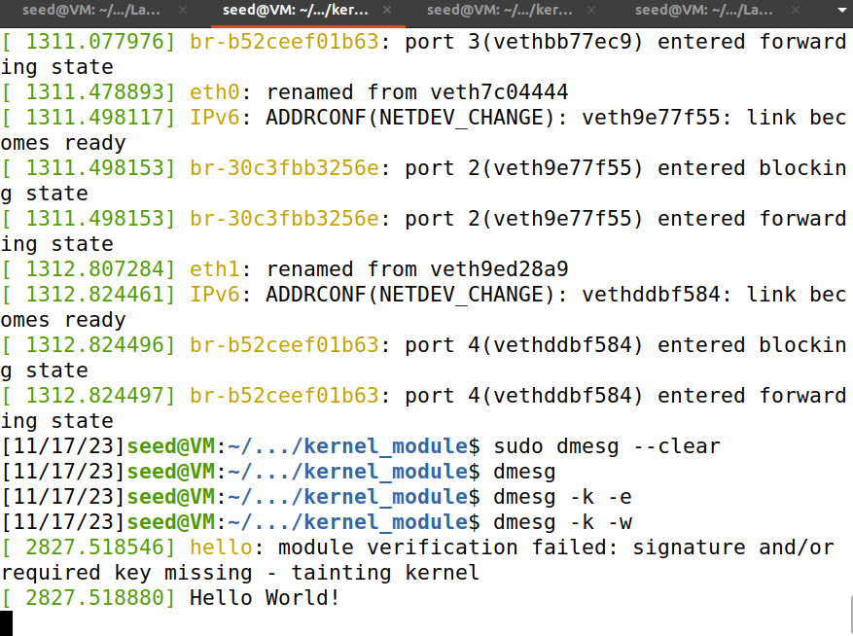

Then I performed the next command which lists the module and after that I removed the hello module.

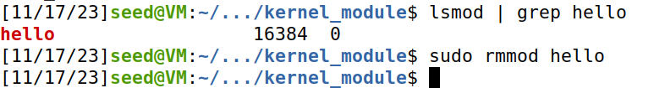

As a result, I can see the Bye World message where I have put the terminal to wait for kernal module messages.

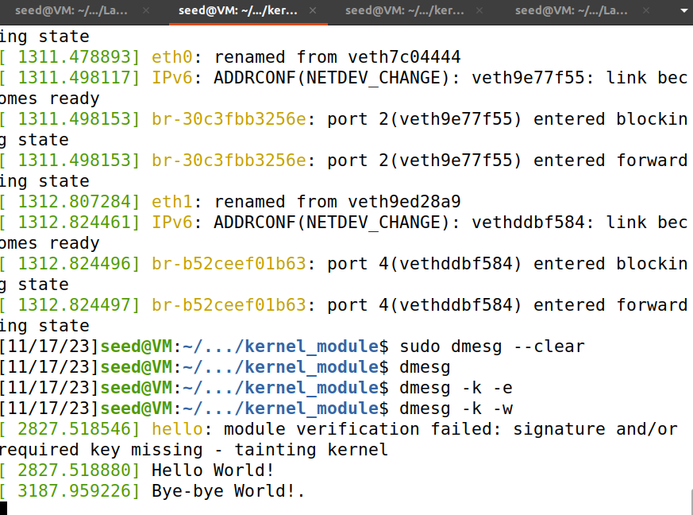

Now just for a good measure I used the command as visible below which shows information of the hello.ko kernal module.

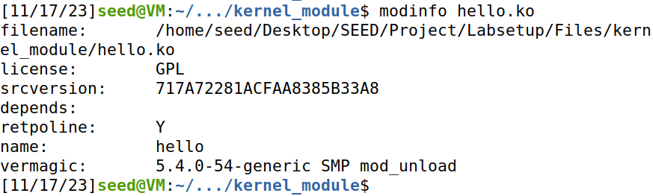

## Task 1.B

I made the changes in the given code for this task which are visible along the comments.

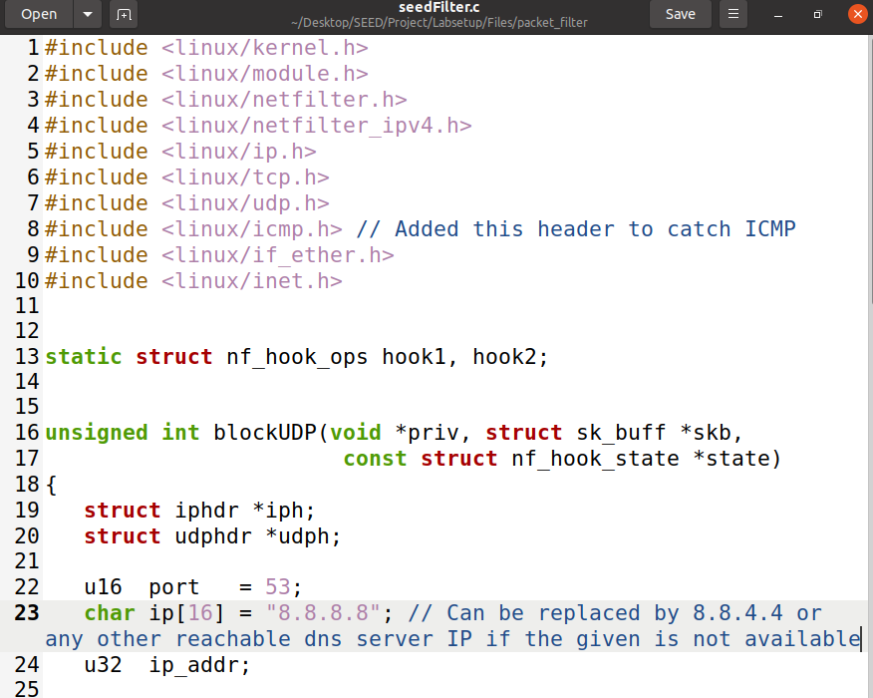

### Subtask 1

In my case the dns server at 8.8.8.8 is available and the link provided. Moreover I can dig to this so it is alright.

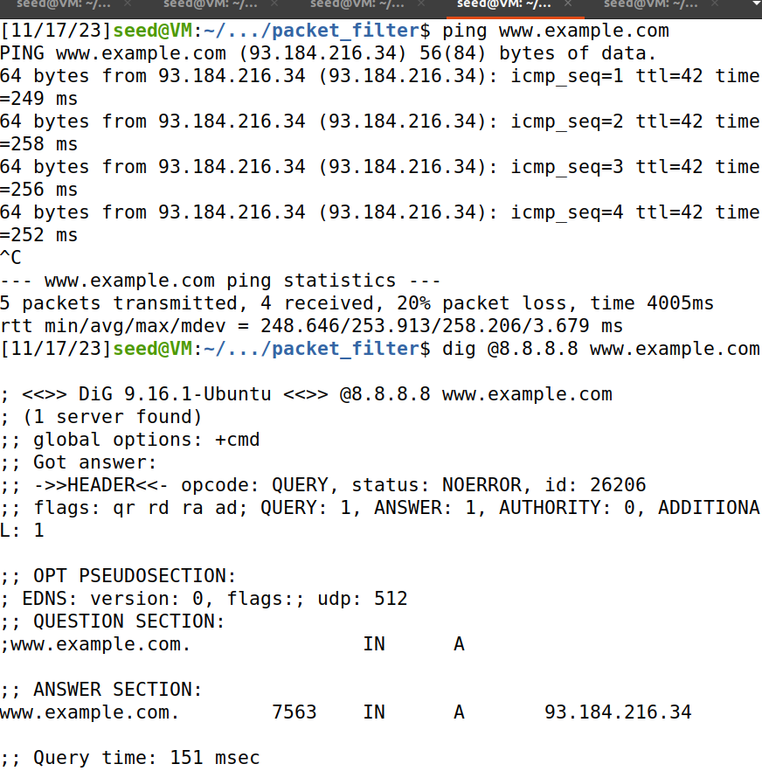

After I make the files I ran this kernal module and ensured if the module is there now in working.

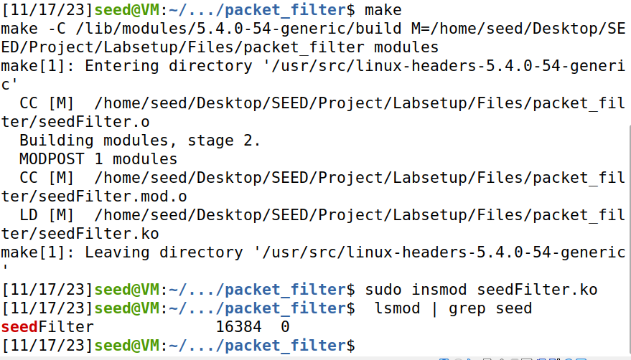

Here I can see the new kernel module message caught proving it to be in progress along with the packets it is capturing now.

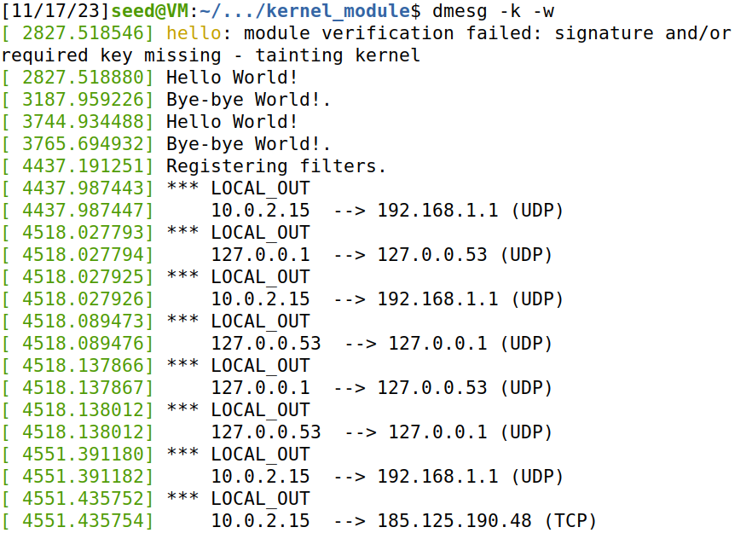

When I digged again the module started dropping these packets which means it is being blocked.

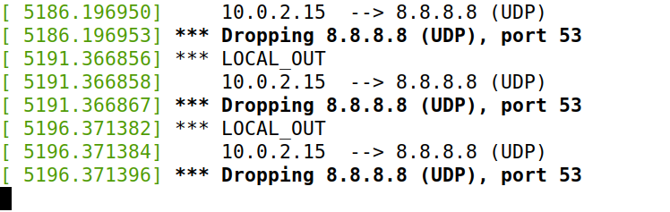

And now I can see that the digging got timed out.

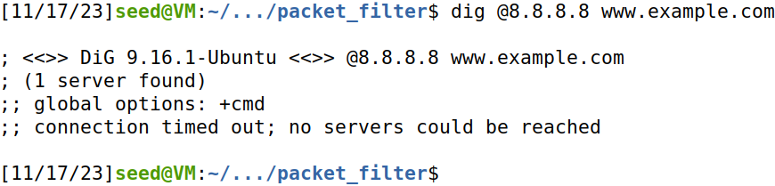

Removing the module.



### Subtask 2

Now cleaning the compiled program and copying the provided code to a new file to make modifications for this task.

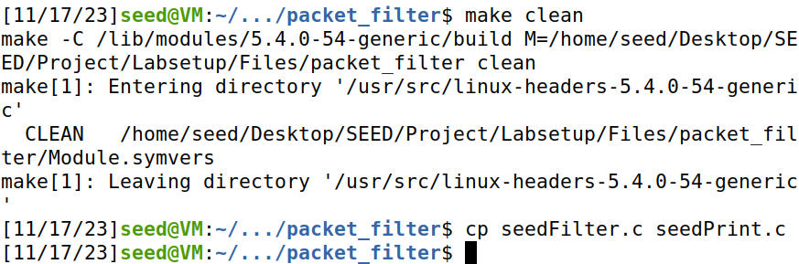

Then I added more hooks.

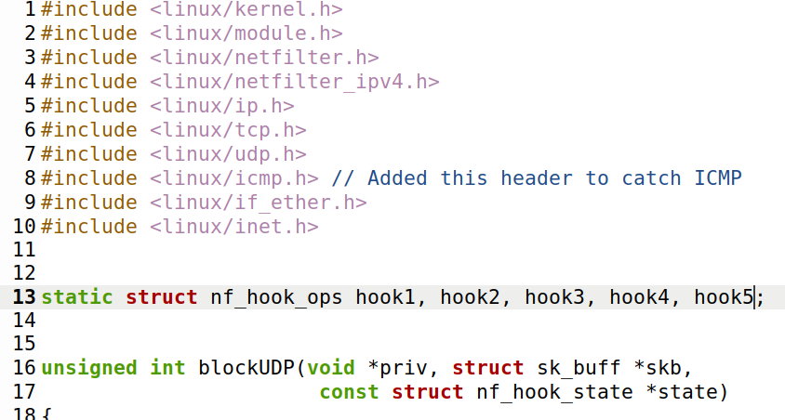

Then I added the filters to be registered according to the hooks and instructions provided.

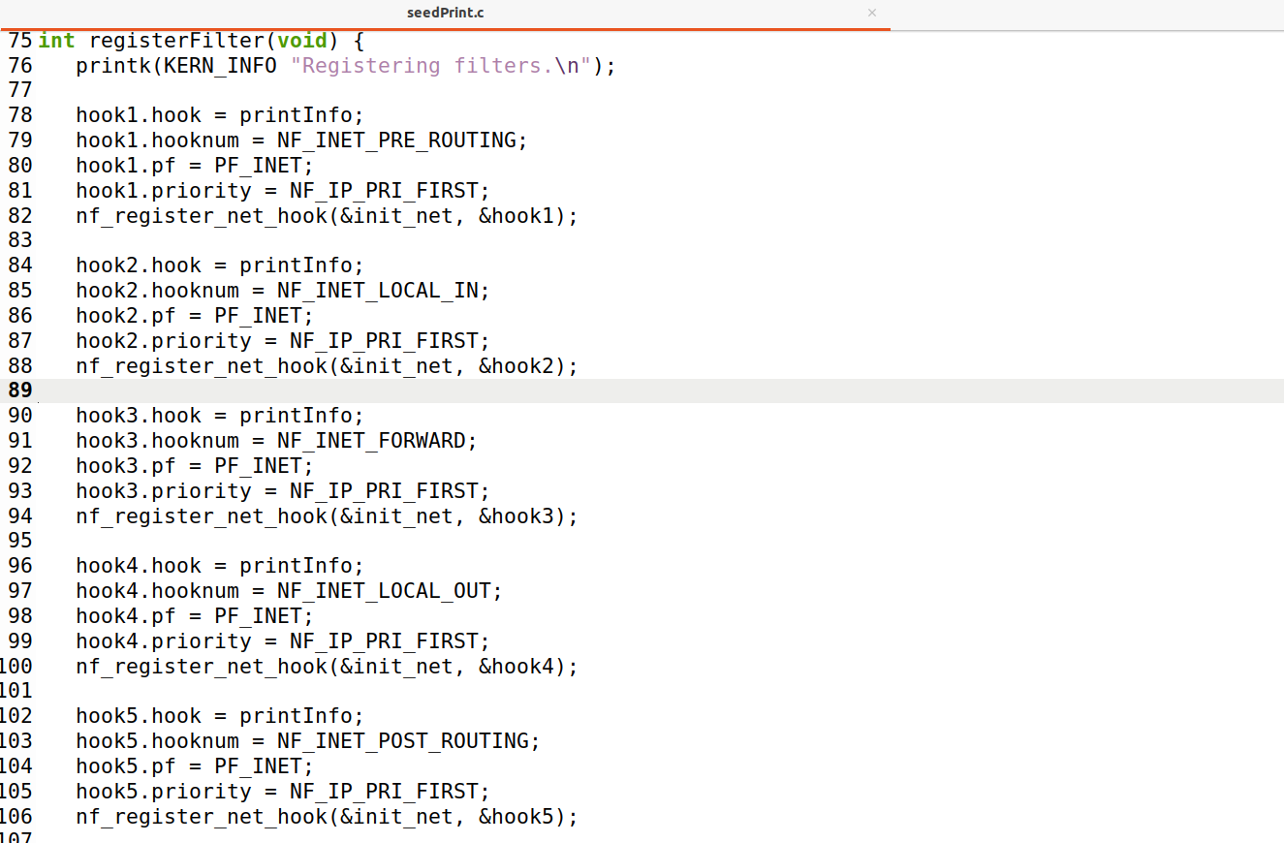

As well the unregistering for the filters accordingly.

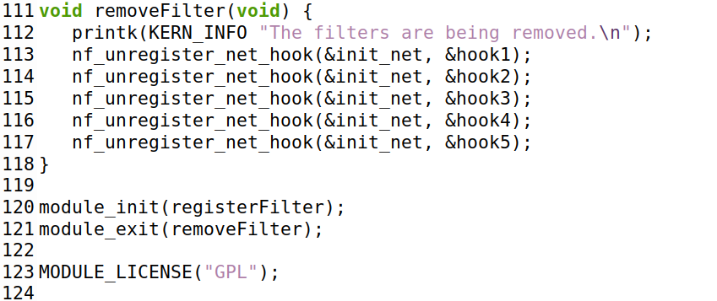

Made the following changes in the MakeFile as seen on the first two lines.

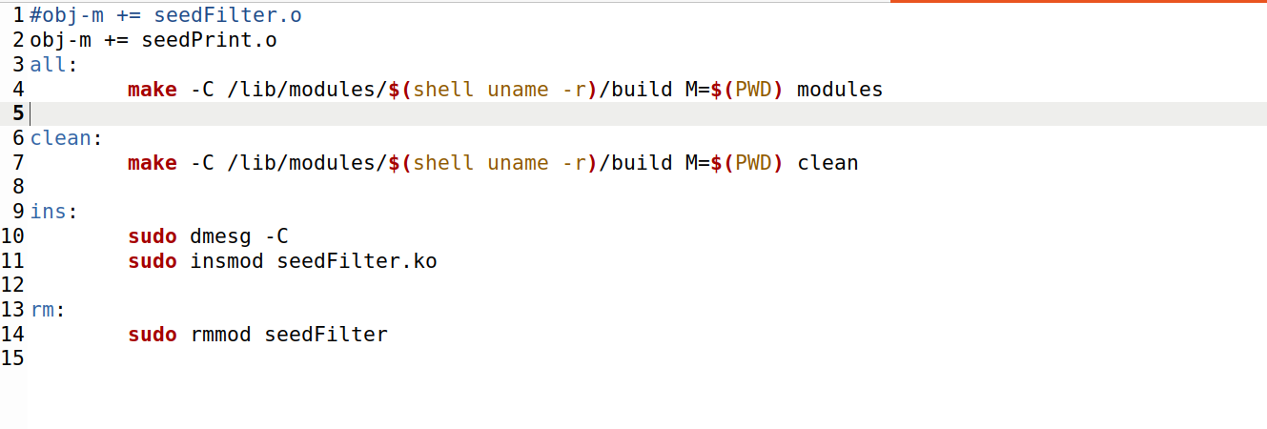

Now I compiled this code.

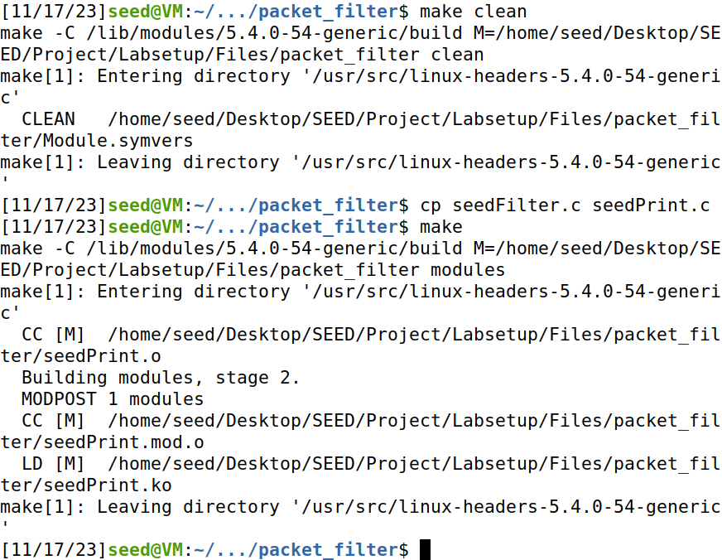

I initiated the kernal module.



As visible the hooks are working.

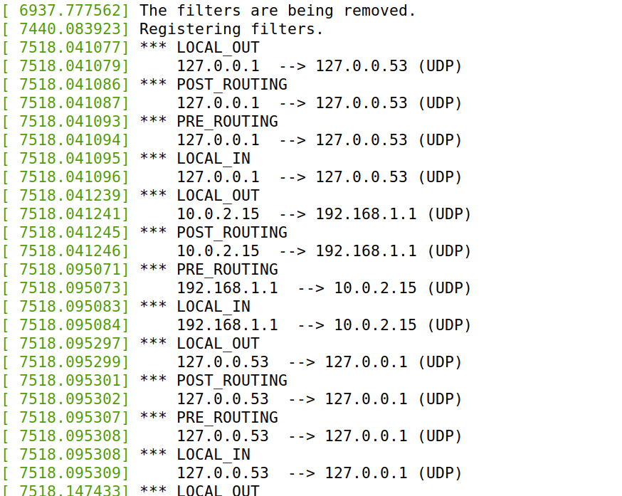

Now to see if it is also going to get information when we target our target.

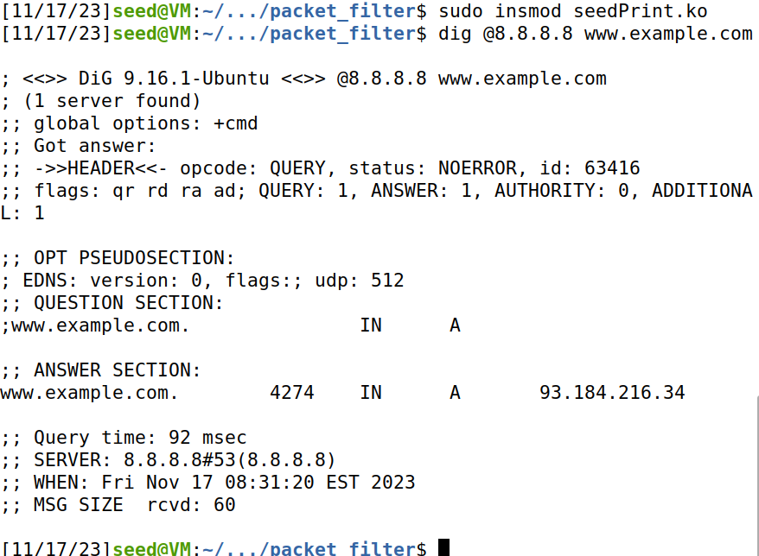

LOCAL_OUT is the spot from where we dig the target then POST_ROUTING is when the packet is going from our machine to dns server then PRE_ROUTING is when the packet comes back from the server to the machine and then we get a LOCAL_IN. There is no FORWARD as it is on the loader but basically it is useful for forwarding the packets to another destination.

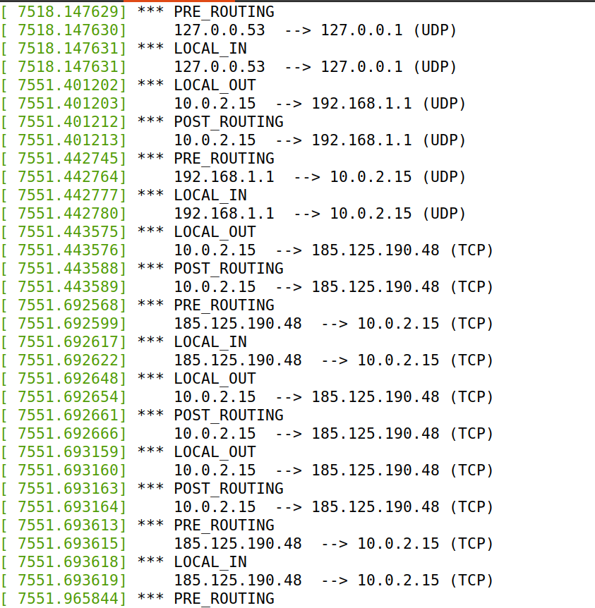

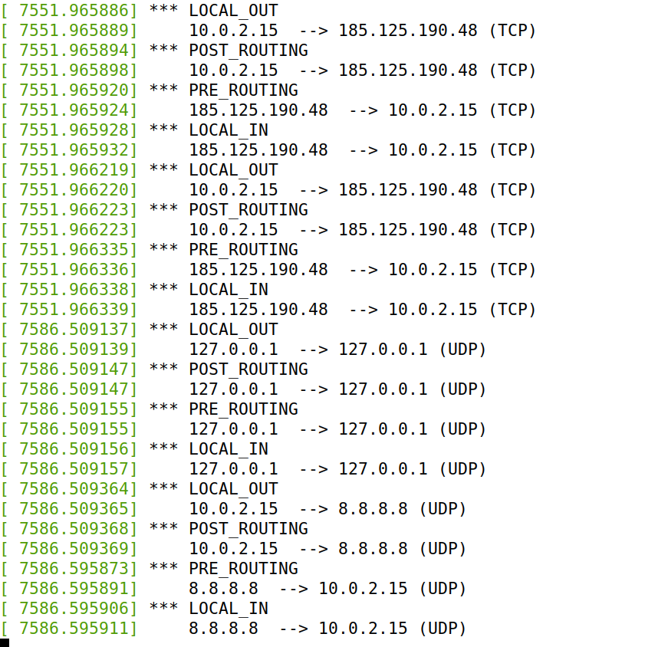

I removed the module now.



And the filters are cleared by the above step.

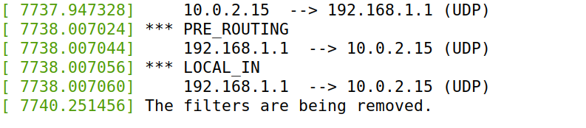

### Subtask 3

I pinged from HOST A to the SEED VM.

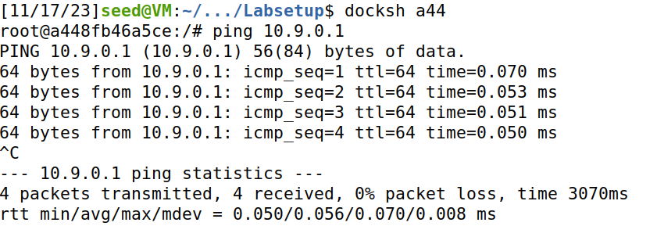

I tried to telnet into SEED VM from HOST A which I was successful at after which I closed the connection.

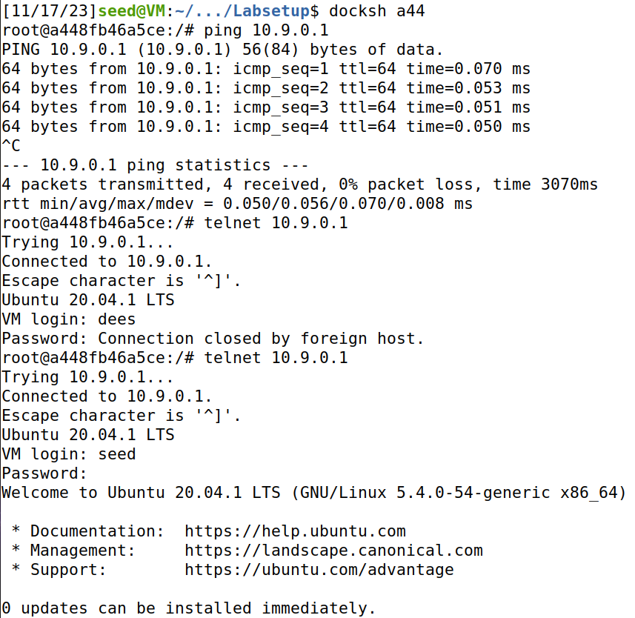

I copied the file to a new file to use it for this subtask.

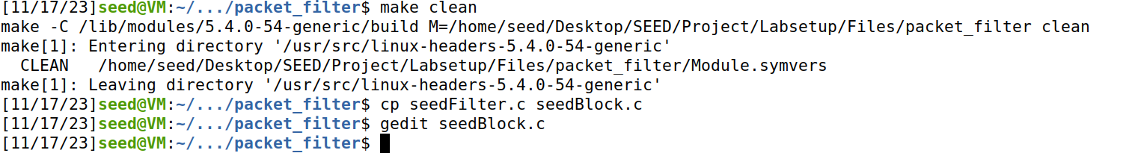

I added the hooks and added these details for hooks.

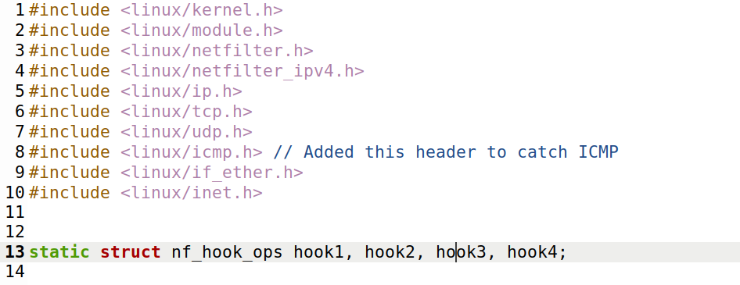

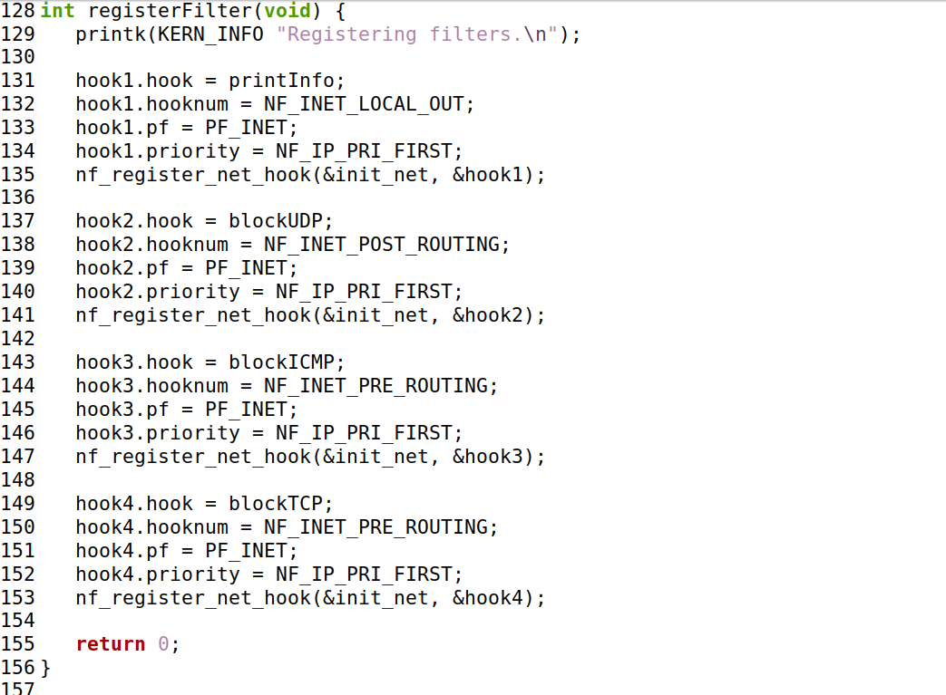

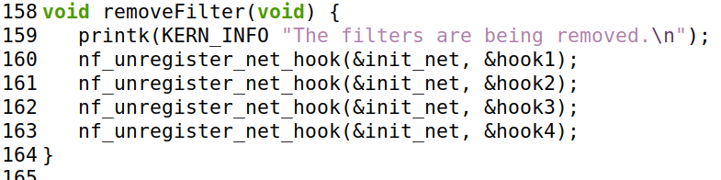

And I added the following functions.

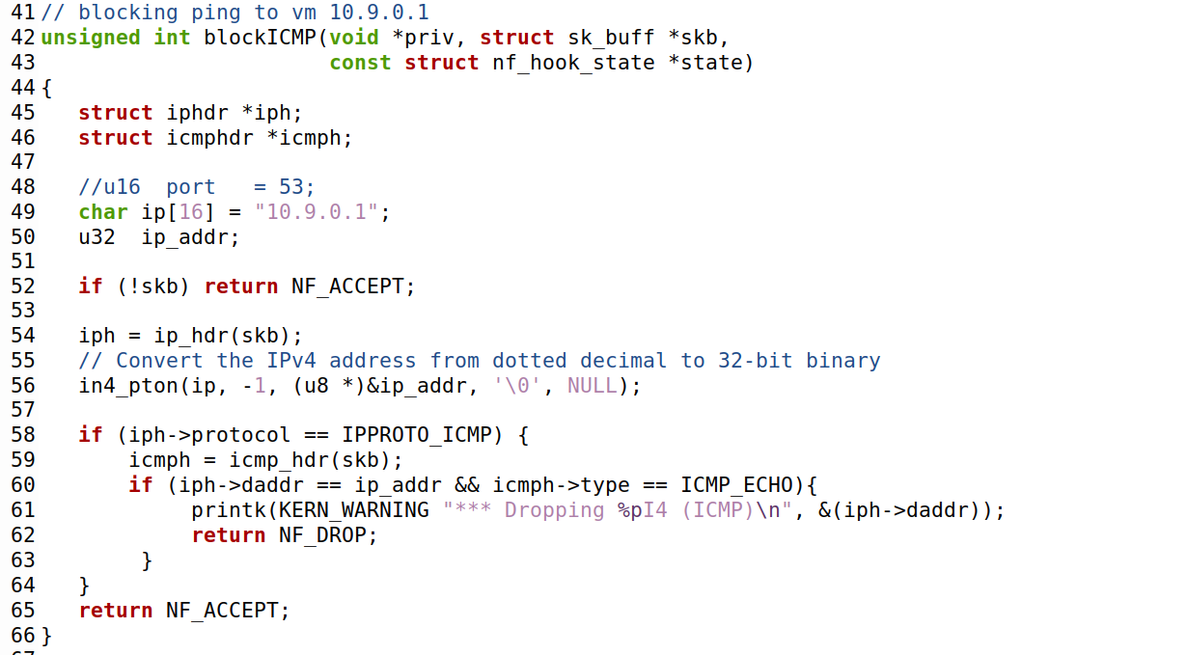

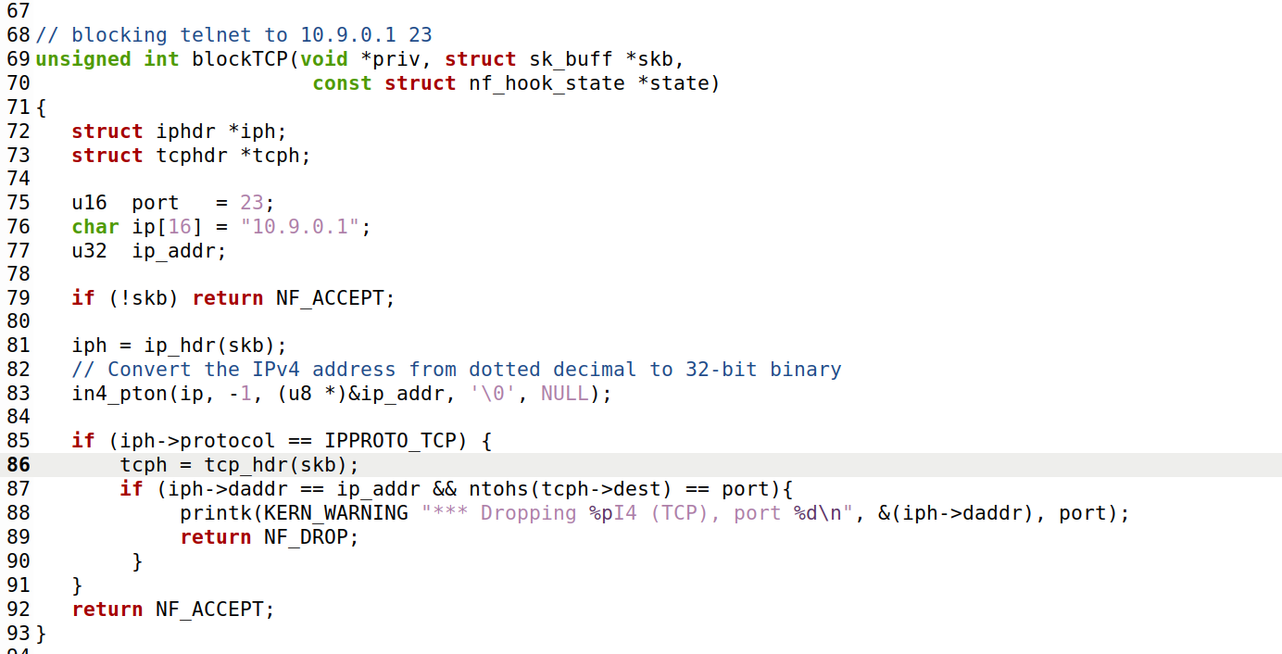

I changed the MakeFile.

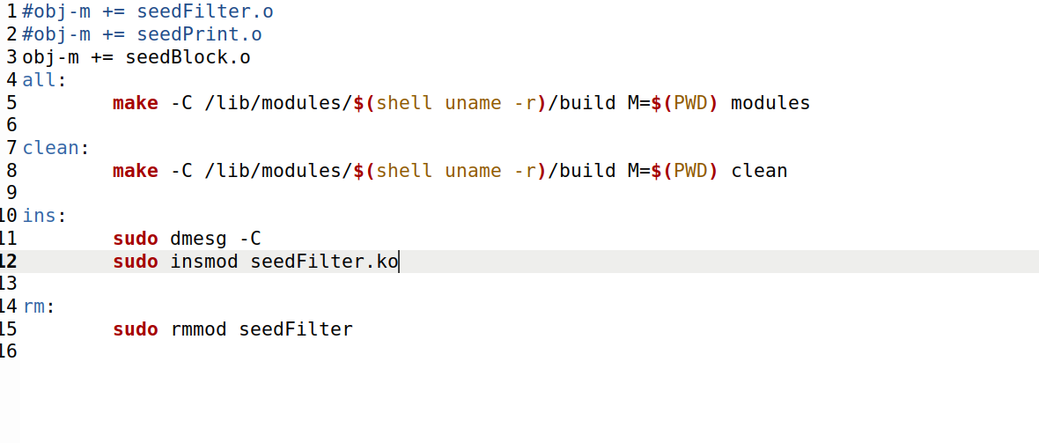

Now I compiled the program.

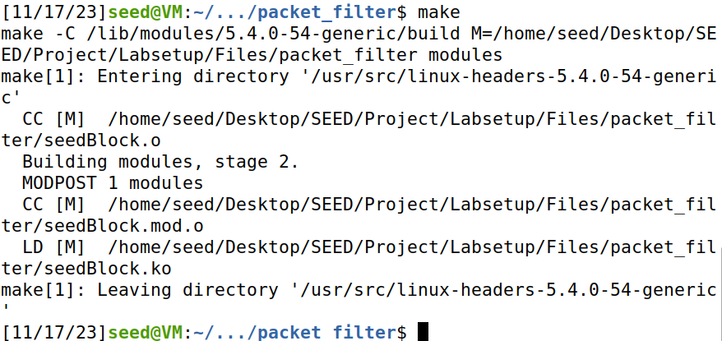

Now initiating kernel module.



Module has started.

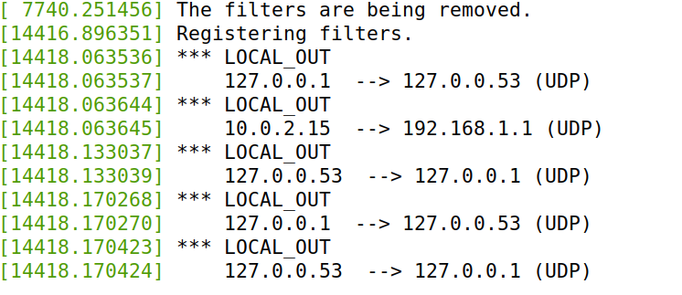

When I pinged from HOST A to SEED VM the packets were dropped.

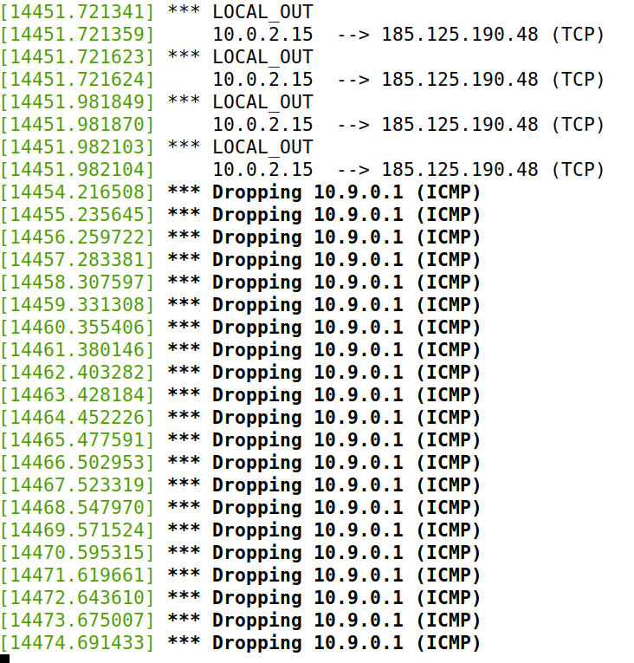

Then I tried to establish telnet connection from HOST A to SEED VM.

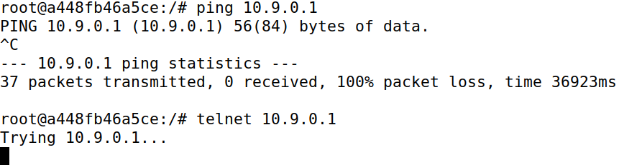

Which evidently got dropped and tells that I have succeeded in this task. After this I removed the module and the filters got removed like the end of the last subtask.

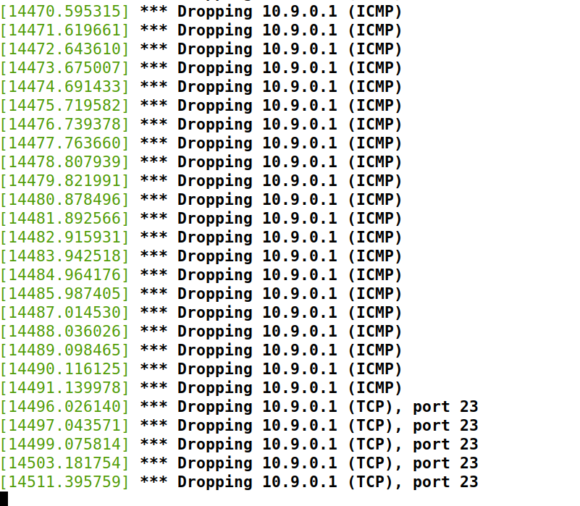

And I stopped the dmesg -k -w as it is no longer needed.

# Task 2

These are the docker rules currently where it tells 127.0.0.0/8 is not the address of the docker. To check with line number just add –line numbers on the end of the command shown in the screenshot below.

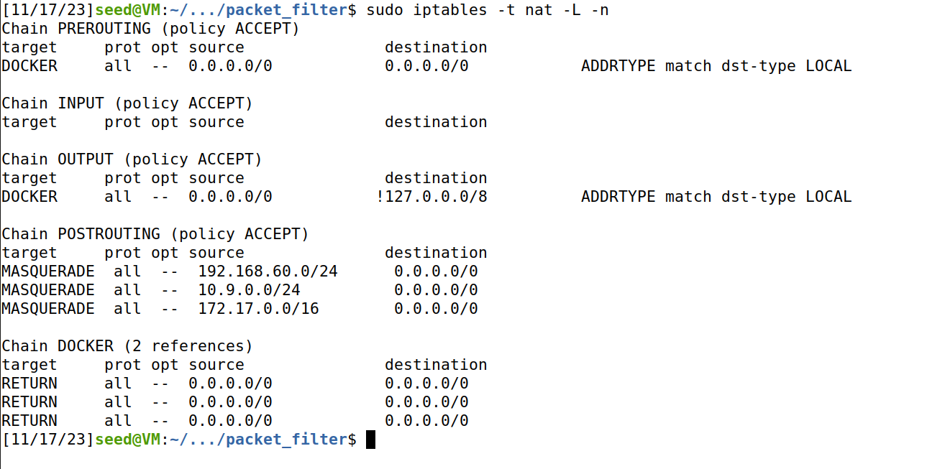

Host A has this for IPTables which is empty.

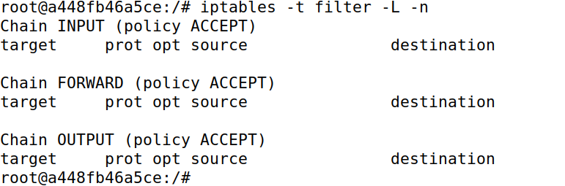

In Host A the nat tables are as follows.

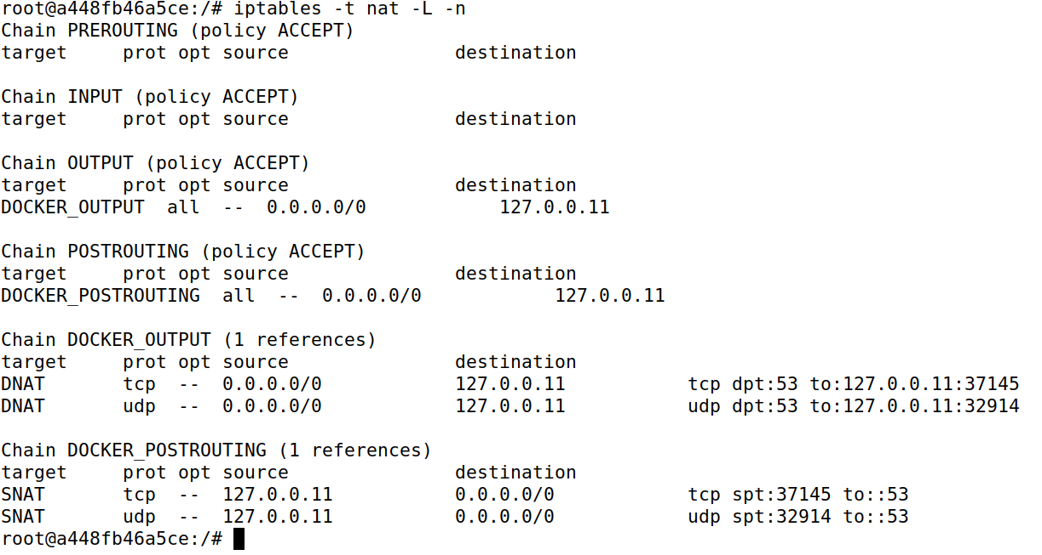

For confirmation I checked if the Seed Router is working so I tried pinging and establishing telnet connection which I closed after successfully checking.

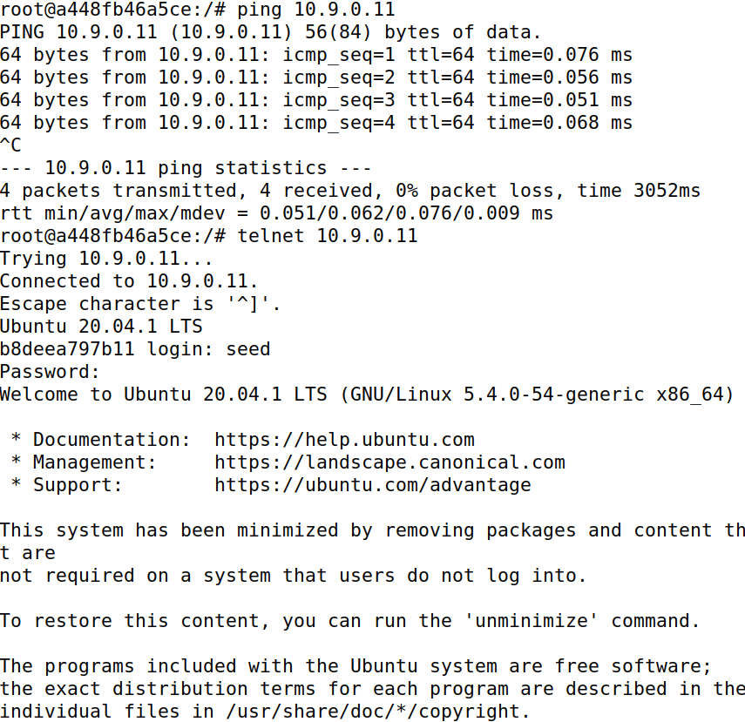

## Task 2.A

Now I set the IPTables for the Seed Router.

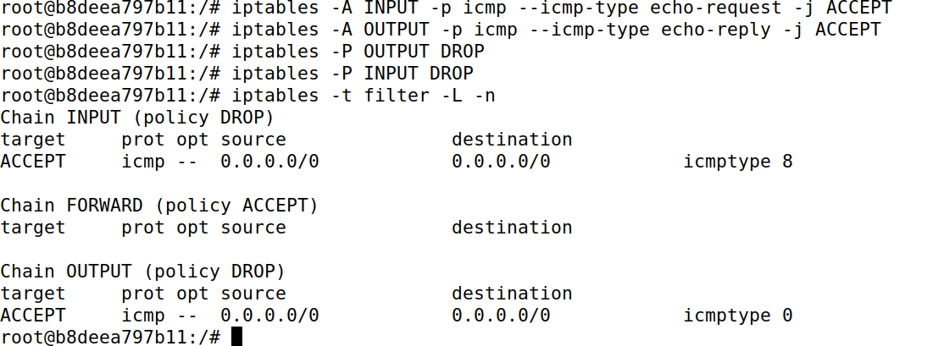

Now when testing pinging it was successful, but telnet connection wasn’t established.

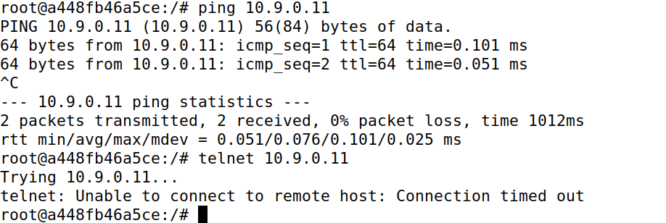

I cleared the IPTables for the next task.

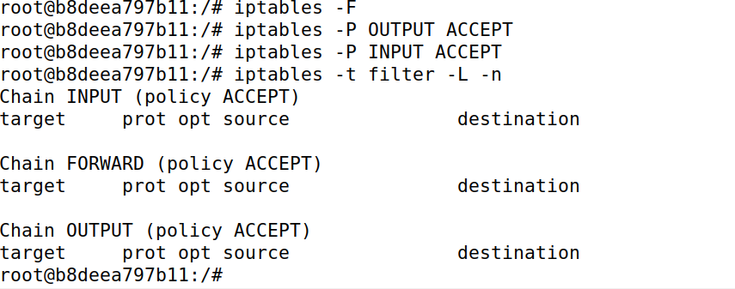

## Task 2.B

After setting the rule in Seed Router IPTables look like this.

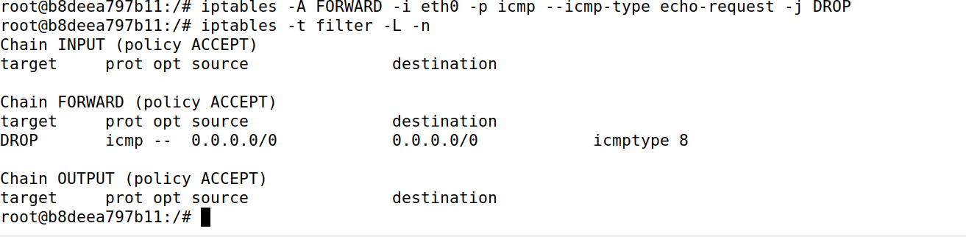I can ping the Seed Router from HostA but I can’t ping the inner Host1.

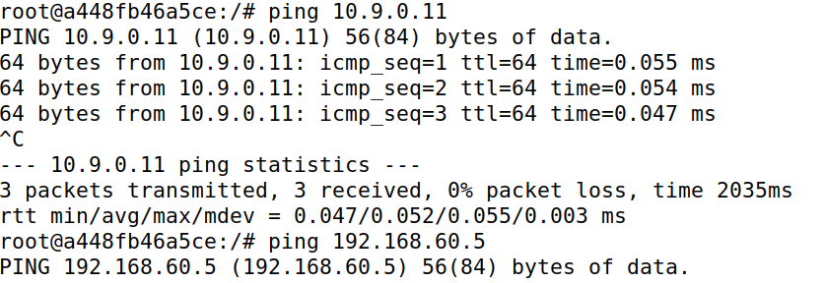

I can ping to outer HostA from inner Host1.

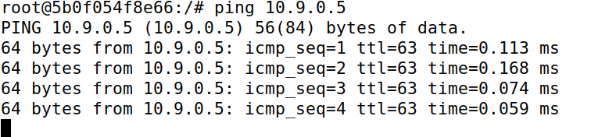  
I made further modifications by setting more rules.

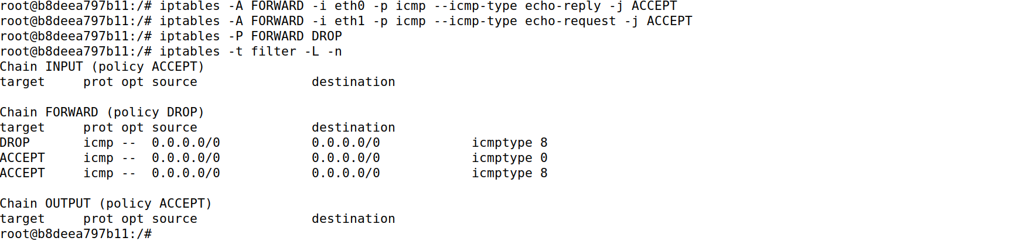

Now I can ping to the Seed Router but can’t ping or telnet Host1.

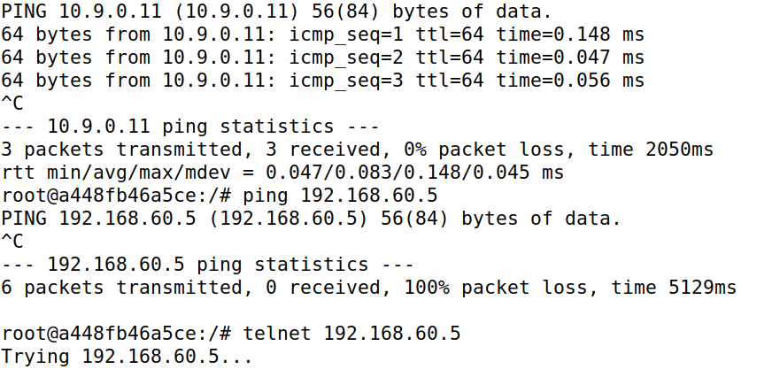

I can ping from Host1 to HostA but I can’t establish telnet connection from Host1 to HostA.

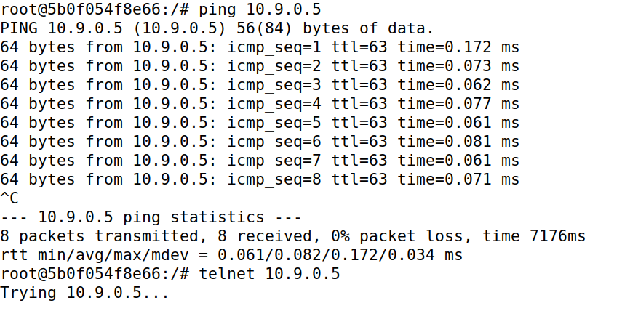

As the task has been successfully done now, I cleared the IPTables of the Seed Router.

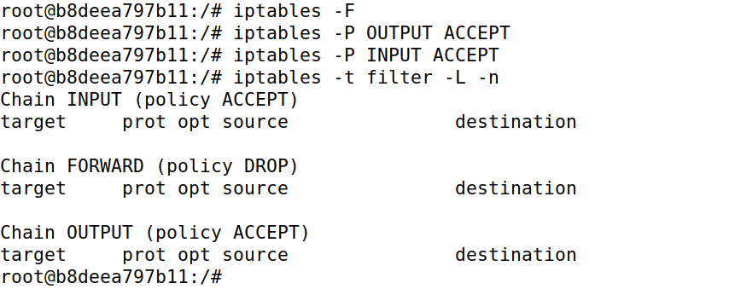

## Task 2.C

External HostA can’t telnet Internal Host2 nor Host3

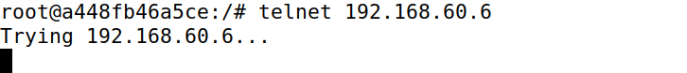

Internal Host1 can’t ping External HostA.

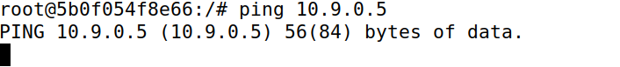

Nor can Internal Host1 telnet External HostA.

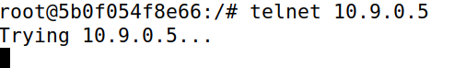

Internal Host1 can telnet and ping Internal Host2 which means this task has achieved all its goals.

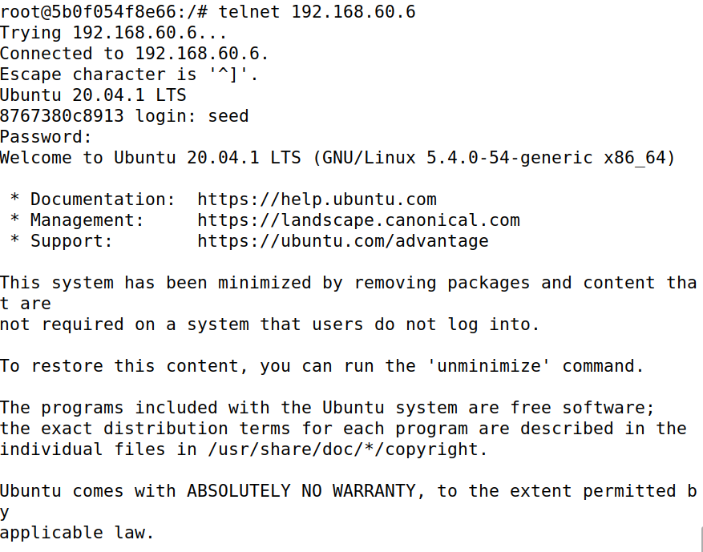

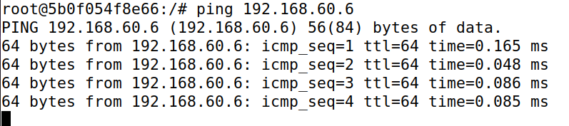

# Task 3

## Task 3.A

### ICMP Experiment

Pinging from Seed Router to Host1 and I found out that the connection remains for 5 to 6 seconds icmp connection can be kept after the job is killed.

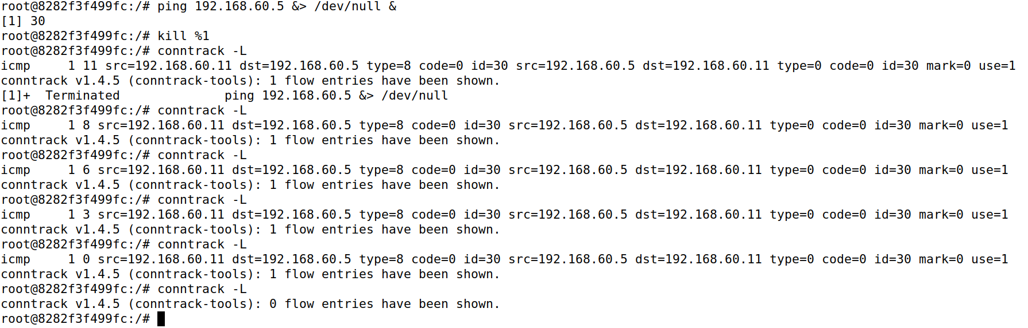

### UDP Experiment

Put Host1 to starting a netcat UDP server.

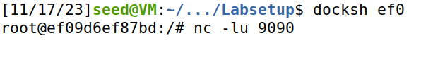

Then sending UDP packets from HostA.

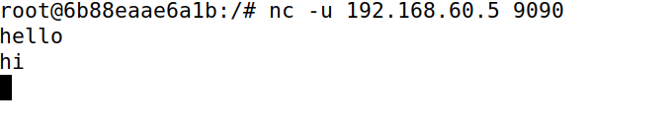

Where I observed about 8 to 13 seconds of udp connection being kept.

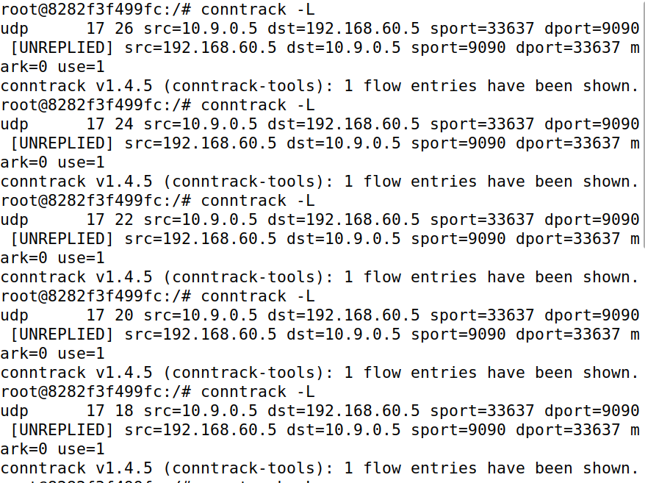

### TCP Experiment

Put Host1 to starting a netcat TCP server.

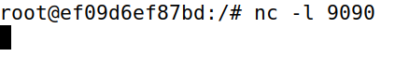

Then sending UDP packets from HostA.

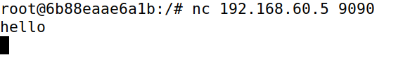

It is evident that router keeps the connection of TCP for as long as possible.

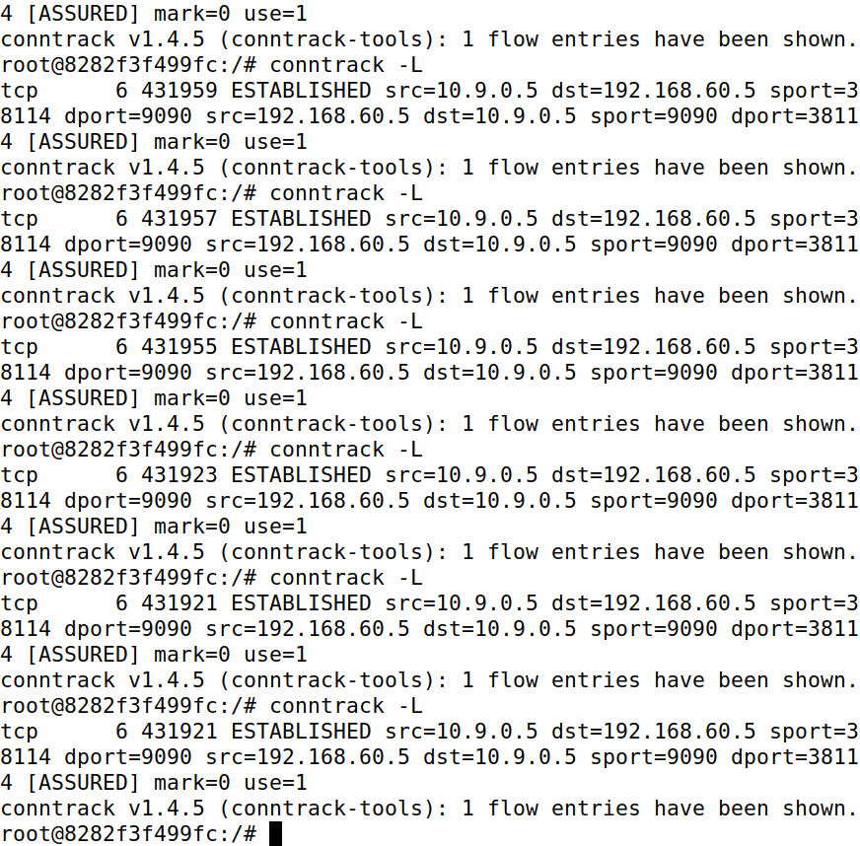

## Task 3.B

Configured the IPTables of the router accordingly.

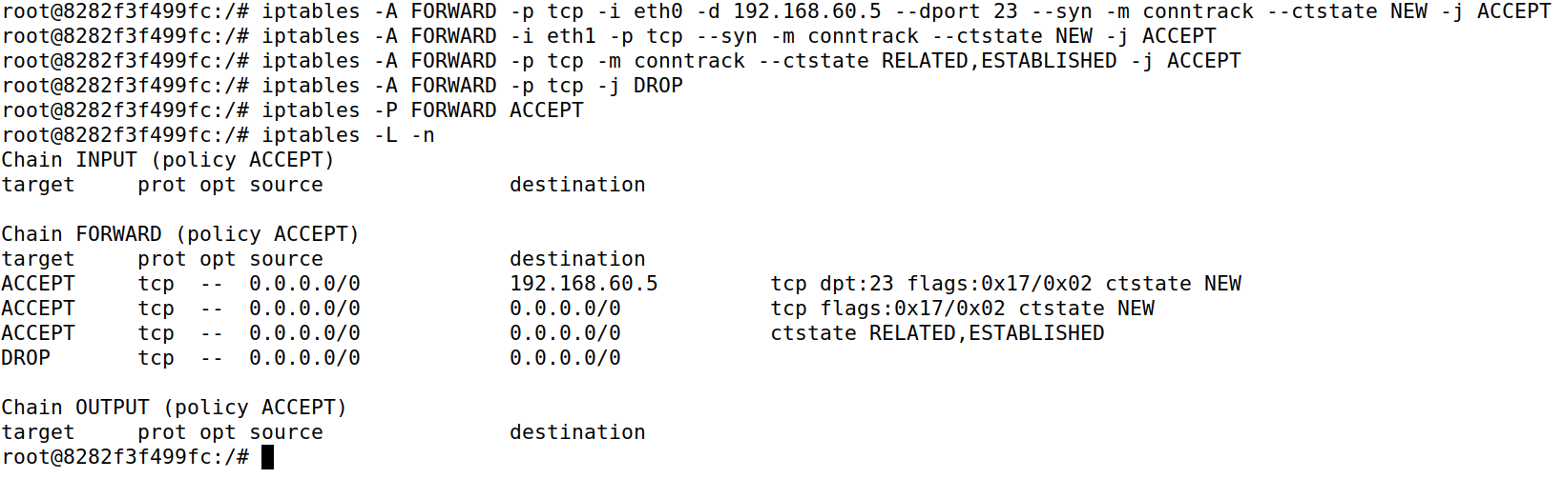

Noticed that connection from Host1 to HostA is allowed.

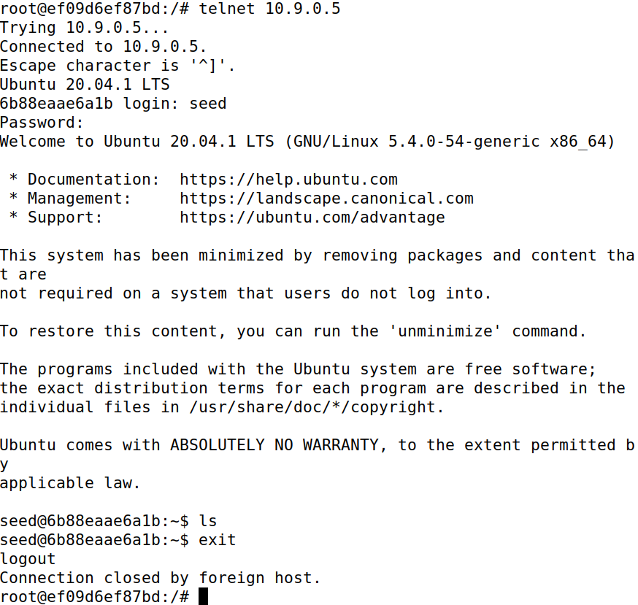

Connection from HostA to Host1 is not permitted.

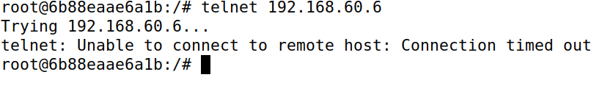

Connection from Host2 to Host1 is allowed.

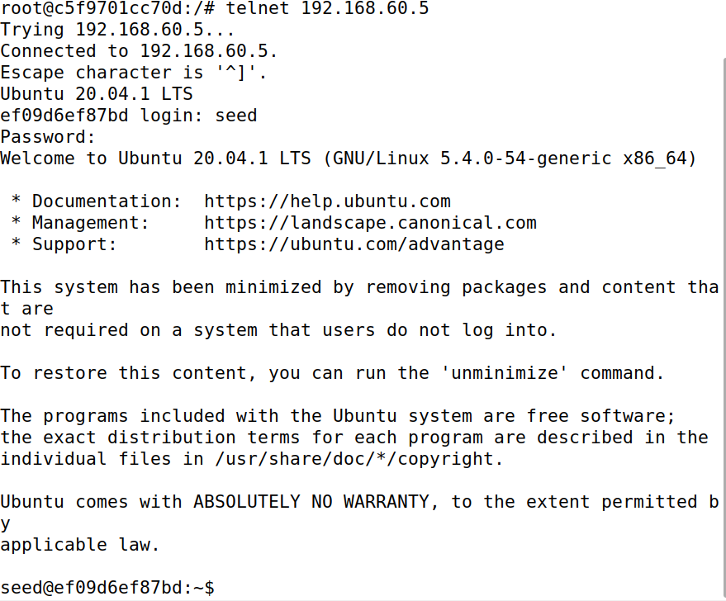

Now flushed the table and made new configurations with rules.

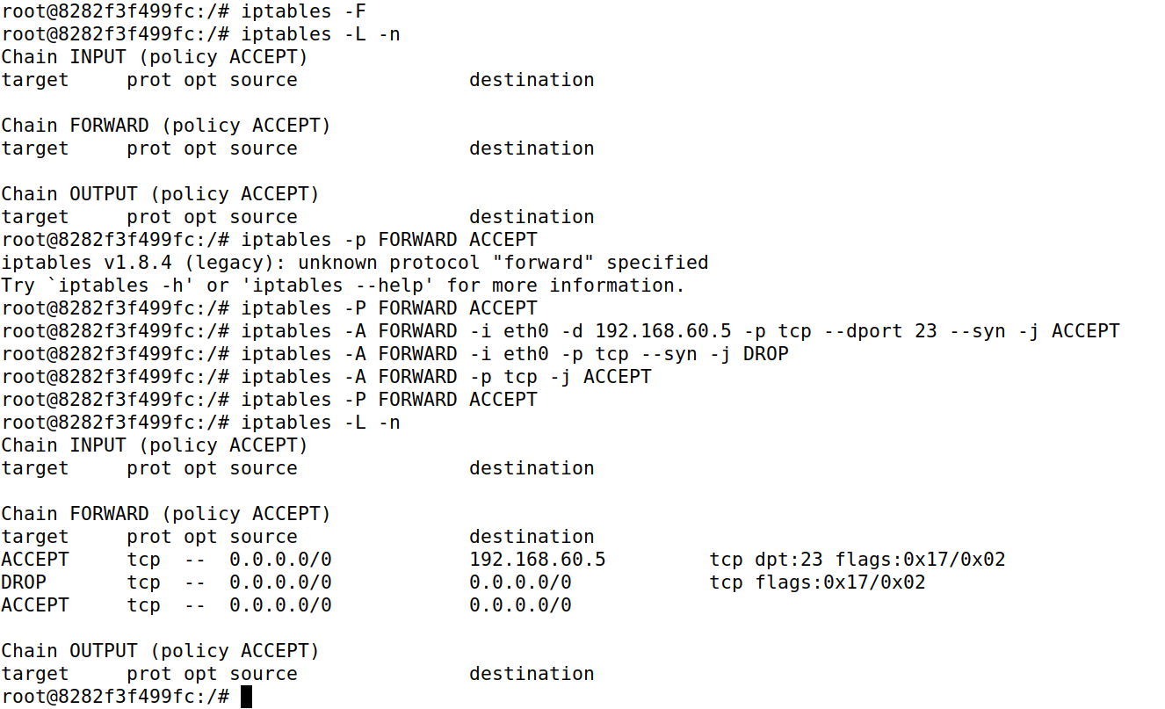

I tried telnetting from HostA to Host2 and it wasn’t allowed but it was allowed to Host1.

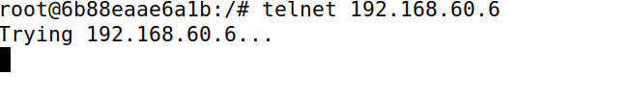

Telnet from Host2 to HostA is allowed and same if for other inner Hosts to outer Hosts.

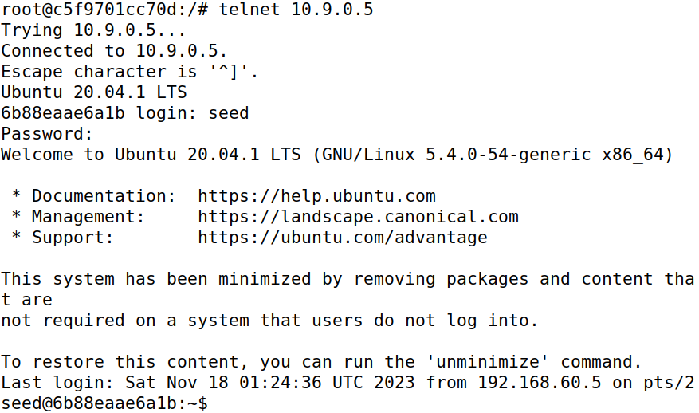

Flushing these rules for the next task.

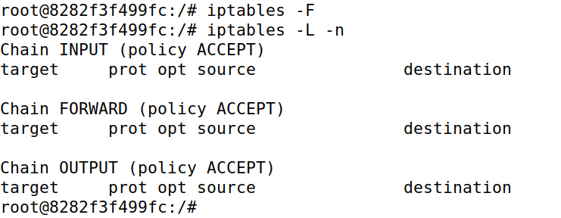

# Task 4

Made the asked rule configurations on router.

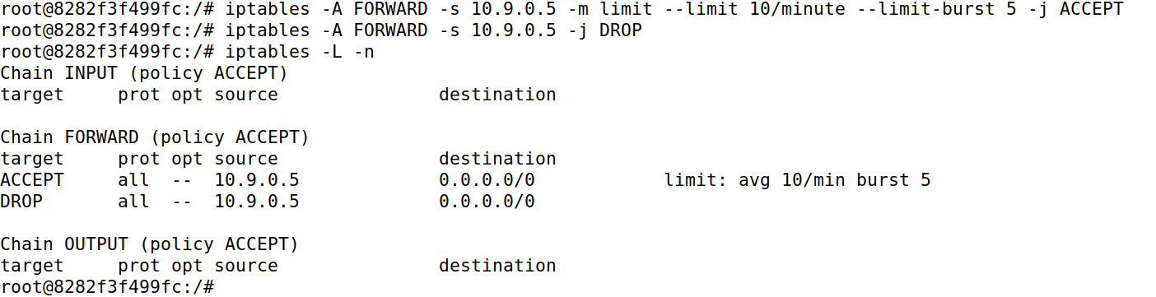

I tried with the first rule, but it didn’t seem to limit the packets but after placing the second rule it started to limit the network traffic from outside HostA.

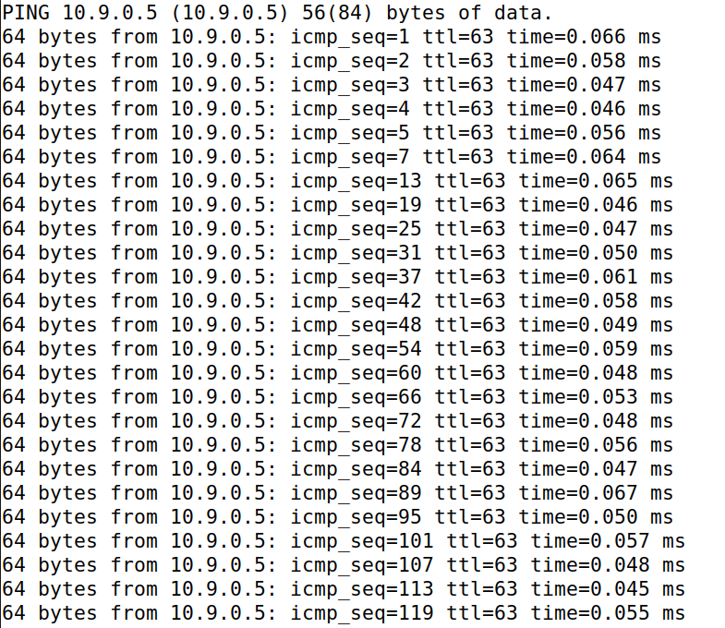

Flushed the routed IPTables for the next task.

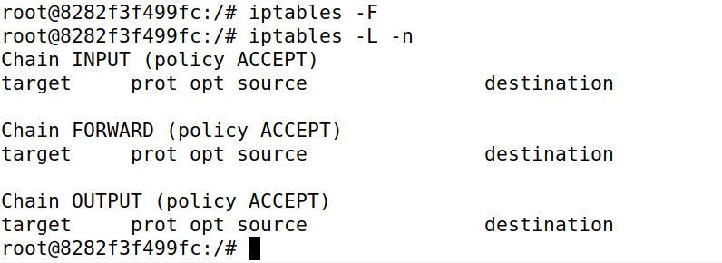

# Task 5

I put this command in all inner Host1, Host2 and Host3.



Placing the rule in router.



From HostA I sent this packet to router.

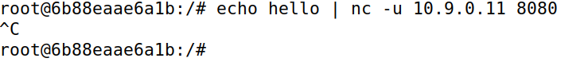

I only received a packet in Host1.

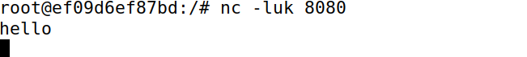

Added two more rules on the router.



Now checking the nat IPTables for the rules placed.

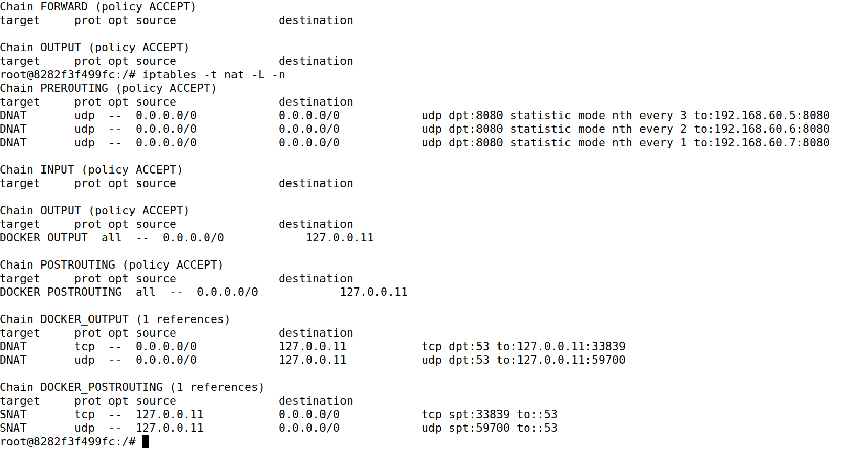

Again, from HostA I sent this packet to router.



I only received a packet in Host1 only.

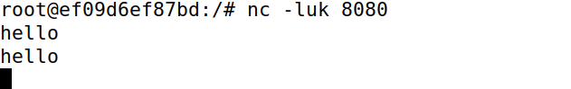

Then I send again the packets to router from HostA and I found that each time a packet is sent it is sent to another internal Host which makes load balancing till here a success. So it can be said that if I only put uc -c 10.9.0.11 8080 and not used echo, I would receive packets in only in one of the internal Hosts but when I put delay in typing and entering then I receive packets in all the internal Hosts.



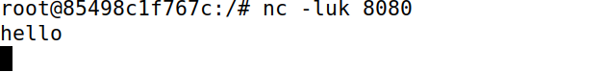

Now checking the nat IPTable with line numbers.

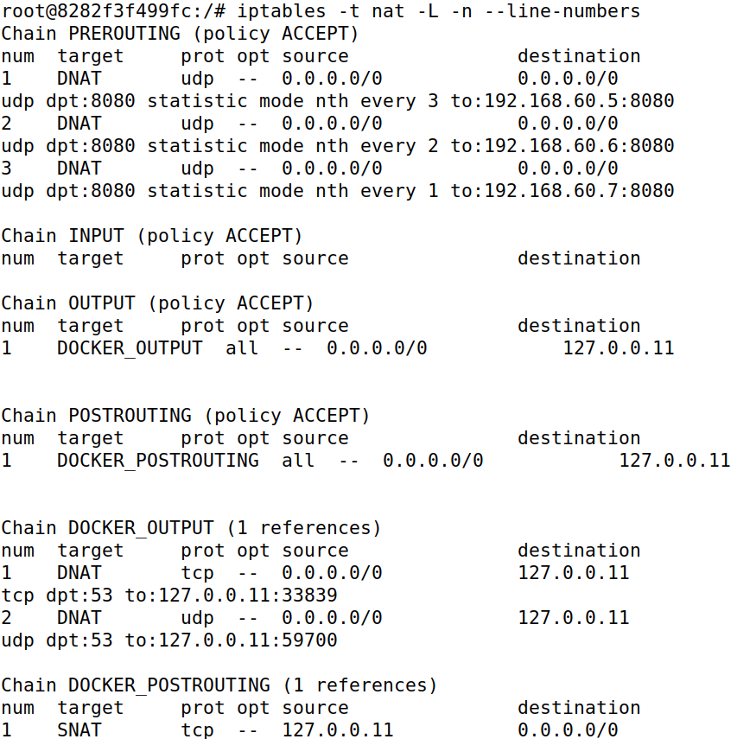

Adding more configurations to the router.

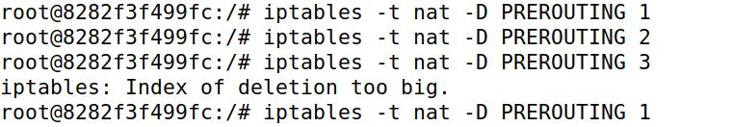

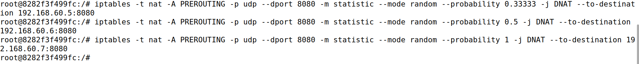

Checking the configurations,

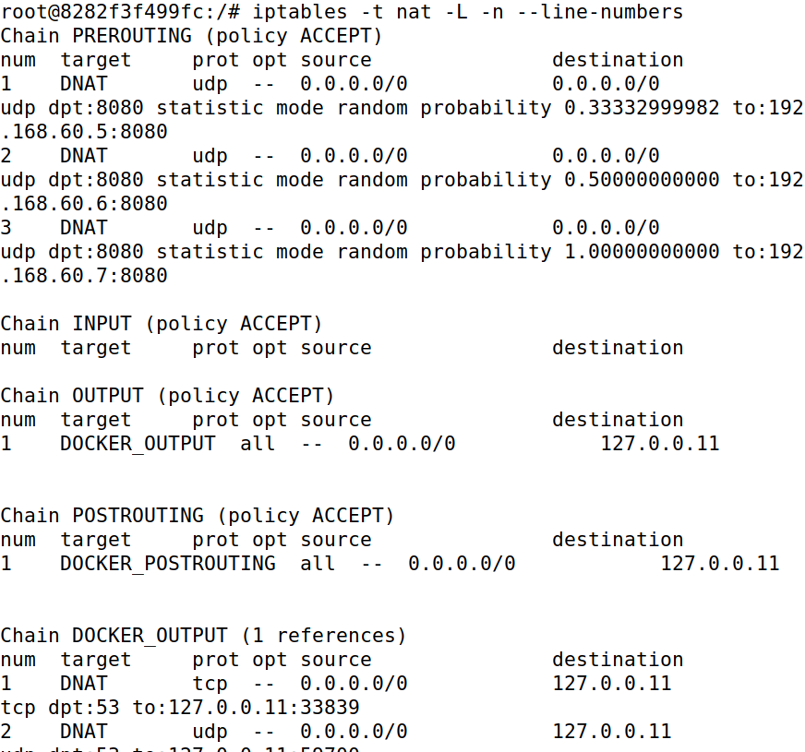

I have sent packets, and it is based on probability now but randomly. Given it is also based on round robin, so it gives it to another process.

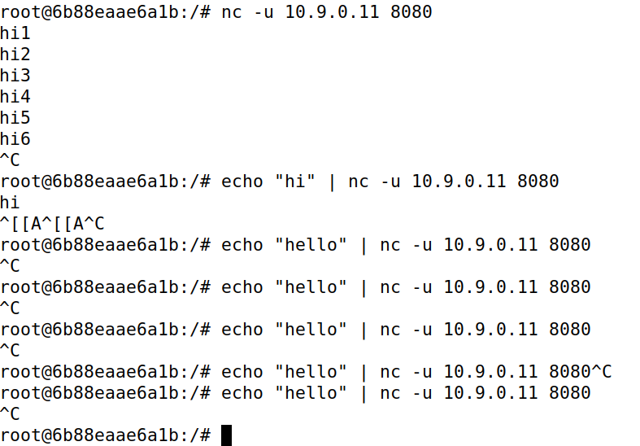

Host1 got these.

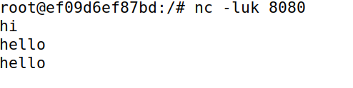

Host2 got these.

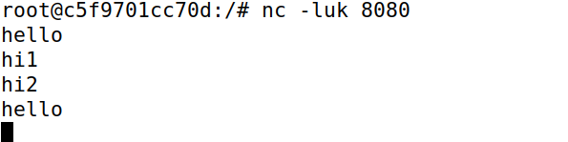

Host3 got these.

